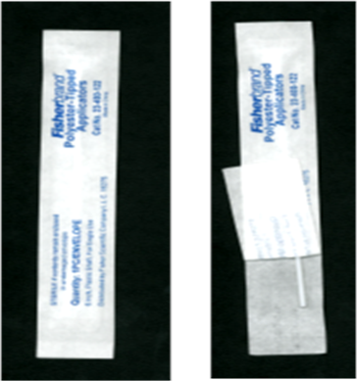**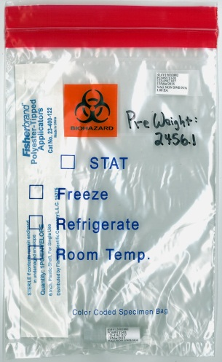Vaginal Self-Collected Vaginal Swab for MTN-027**

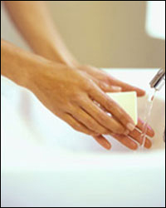



**1)** Wash & dry hands,

Then undress from the

waist down.

**2)** Open Ziplock bag.

Remove cryovial cap

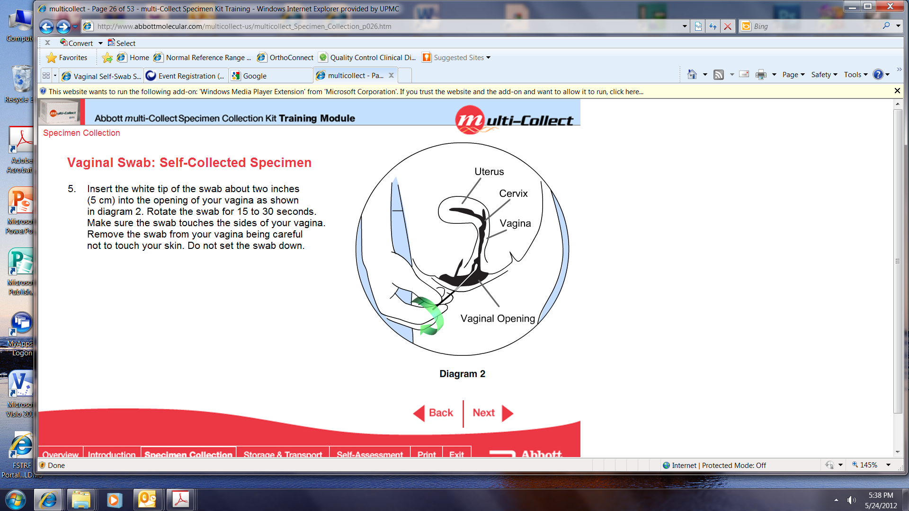 and swab envelope from bag. **3)** Open wrapping on the end

opposite of the soft tip **4)** Grasp swab as pictured **5)** While separating the labia with

*Make sure swab wrapper gets one hand, use other hand to placed back into ziplock bag hold the plastic swab shaft

 between thumb and forefinger.

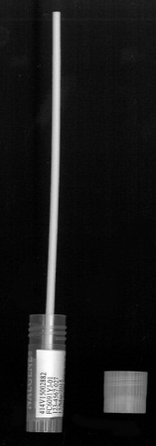



**6)** Insert the soft tip of the swab into your vagina

approximately 2 inches (about the length of your

little finger). Spin the swab for 10 seconds (counting

thousand 1, thousand 2…) in a circular motion,

attempting to touch all walls of the vagina. **7)** Insert swab into vial

(hold upright) **8)** Give the cryovial with swab and cryovial cap to the staff so they can break off

**NOTE: If the swab is dropped, please ask for another** the shaft. They will put the capped cryovial and shaft into the ziplock bag. **collection bag and repeat the entire process** **above.**

MTN-027 Self-collected Vaginal Swab Instructions, with staff assistance 17Apr2015